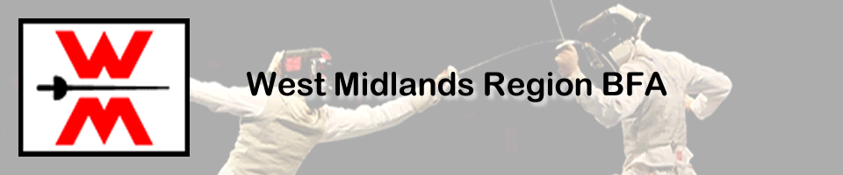

Presidents Cup - Mixed Team Fencing Competition
Saturday 12th December 2026
Format: Team of 3 comprising 1 Foilist, 1 Epeeist, 1 Sabreur, with a mix of male & female fencers.
Ideally, all fencers should be from the same club although some discretion will be accorded to clubs with limited female fencers or sabreurs. This event is primarily aimed at intrermediate and beginner fencers.

Date: Saturday 12th December 2026
Venue: University of Birmingham Sports and Fitness Centre
Edgbaston Park Rd, Birmingham B15 2TT
Access: There is car parking on site, accessible off Edgbaston Park Rd.
Entry fee: £48 per team payable by bank transfer to West Midlands Region Fencing
Sort code: 30-96-12, Ac. No: 44077468, Use club name as a reference.
Check in: Closes 11.30 am.
Entries to: R.Simmonds
Email to: rwsimmonds@btinternet.com
Closing Date: 4th December 2026
All fencers must be members of British Fencing. Membership will not be available on the day.
All fencers must be 13 or over on 12th December 2026
Competition will be fenced on conductive pistes. Relay format will be fenced throughout the competition. Some electric kit may be available on loan. Please check in advance of event.
Competition will run as a poule unique.
For safety reasons, British Fencing regulations regarding clothing and equipment will be strictly adhered to.
Changing facilities are available and there is a Costa on site..

Presidents Cup entry form Saturday 12th December 2026

Club: ____________________________

Team Name: ______________________

 | Name | BFC No.
Foil
Epee
Sabre

Main contact:.......................................................

Tel/Mobile no........................................email address:................................................................................
This event is registered with British Fencing for insurance purposes. I understand that the organisers do not accept responsibility for any accident, loss or damage sustained during the event.

Signature of main contact................................................

